**Requirements Document**

**Grupo AXO**



**May 2016**

**e-commerce**

# ASSETS INTERCHANGE

In order to coordinate the interchange of assets, we suggest a FTP folder (we can use the Express’s Retail cloud net) with the following specs:

* Folder for banners group by month
* Folder for product shoots group by category and season
* Folder for product descriptions, attributes, related products, and reviews group by category and season
* Folder for promotional videos group by category and season
* Folder for promotional banners and campaigns group by category and season

The list of assets requested is:

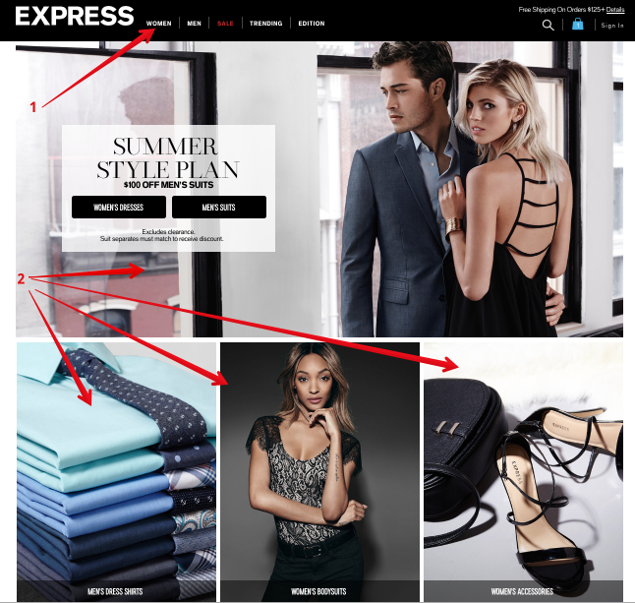

1. Font and size for text used in Express web page
2. Banners used for home, categories and subcategories with the original resolution

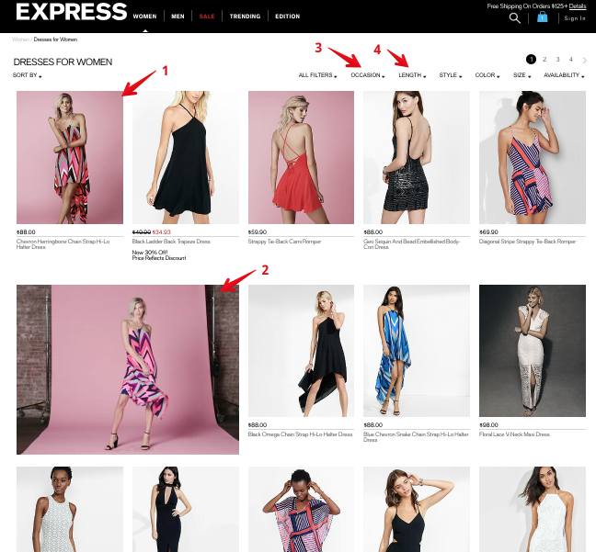

1. Main and first alternative product photos
2. Occasion attribute
3. Length attribute
4. Videos

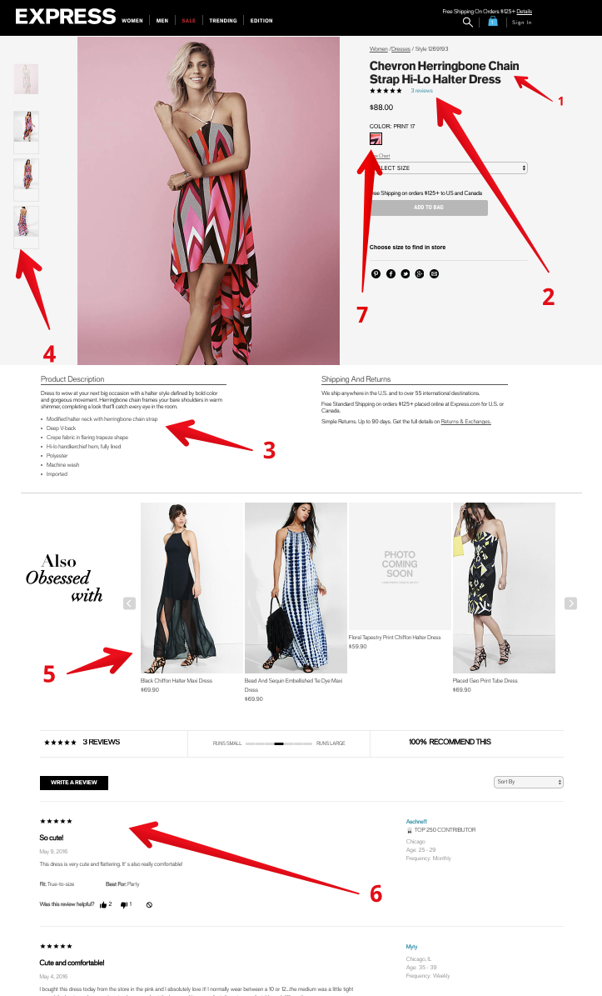

1. Commercial product name
2. Product rate
3. Commercial product description
4. Alternative product photos
5. Related products per SKU
6. Reviews
7. Color swatch

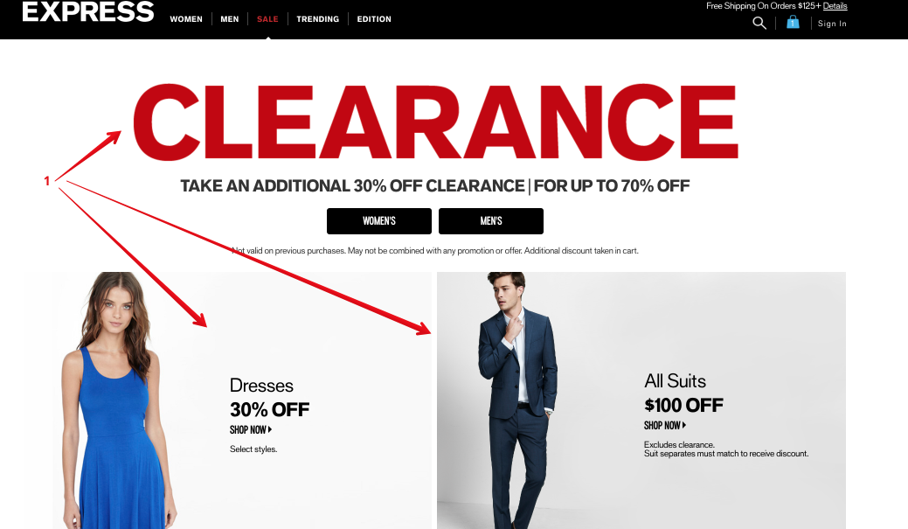

1. Promotional banners

* Promotional and transactional e-mails templates